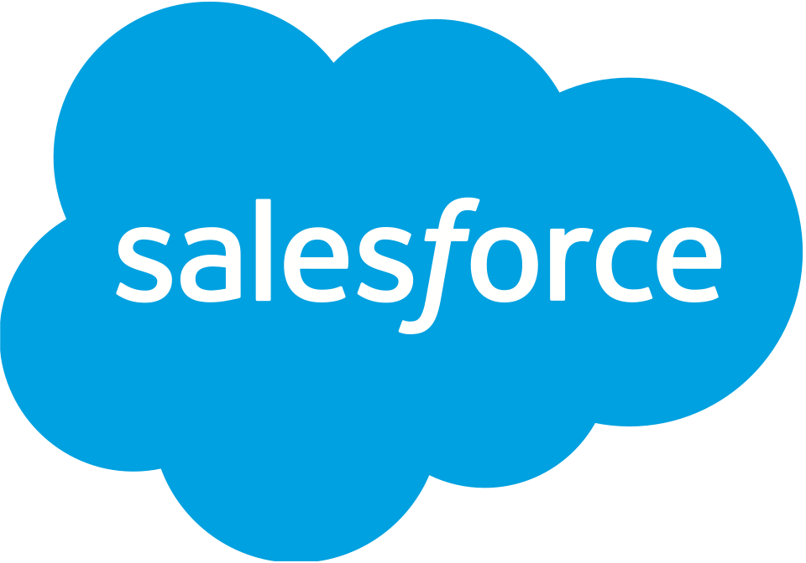

Project Documentation

Project Title: Swift Ship Tracker
Team Members:
1. A B I N E S H. O - Team Lead
Reg. No: 920323205002
NM ID: C0F38BA750A0465824A44807770575B0
2. Adhithya .k- Team Member
Reg. No: 920323205003
NM ID:E5081434B6A5D689A7442E305001AA24
3. Dharanish .k- Team Member
Reg. No: 920323205013
NM ID: 5B16FFA8D11DA9BA5BD4FAEA17A7DD27
4. Aswinth.B- Team Member
Reg. No: 920323205009
NM ID:8C0D97678760C9D804D49EBA7368E715
5.Dhanush .S- Team Member
Reg. No: 920323205012
NM ID: D328AEEE166B143A2374B25F00F5F8FE

SWIFT SHIP TRACKER

User Story
SwiftShip Tracker is designed as a centralized Salesforce-based parcel management solution. It enables customers to book parcels, monitor delivery status, and manage shipment information through an intuitive interface supported by conversational AI. The system manages Parcel, Delivery, Sender, and Receiver information through Salesforce custom objects and relationships. Salesforce Flows automate parcel operations and notifications, while Agentforce AI and Prompt Builder allow customers to retrieve parcel information and interact conversationally. Delivery agents can update parcel status in real time, and Experience Cloud, security controls, reports, and dashboards provide secure customer access and operational visibility.

INTRODUCTION
SwiftShip Tracker is a Salesforce-based parcel management and tracking solution developed to simplify parcel booking, shipment tracking, and delivery management. The system supports the complete parcel lifecycle, from booking and dispatch to tracking and delivery confirmation. It enables customers to access shipment information, while delivery agents can update parcel details and delivery status. The solution uses Salesforce custom objects, relationships, Flows, Agentforce AI, Prompt Builder, Experience Cloud, reports, dashboards, and security controls to provide centralized and efficient parcel management.

1.1 Project Overview
SwiftShip Tracker is a Salesforce CRM solution developed to simplify parcel booking, shipment tracking, and delivery management. It supports the complete parcel lifecycle, from booking and dispatch through tracking and delivery confirmation. Customers can access shipment information, while delivery agents can update parcel details and delivery status.

1.2 Purpose
The purpose of SwiftShip Tracker is to:
- Centralize parcel and delivery information.
- Simplify parcel booking and tracking.
- Provide real-time shipment visibility.
- Automate delivery updates and customer notifications.
- Enable conversational parcel tracking through Agentforce AI and Prompt Builder.
- Improve agent efficiency through Salesforce Flows and dashboards.
- Provide secure, role-based access for customers, agents, support staff, and administrators.

2. IDEATION PHASE

2.1 Problem Statement
PS-1 Customer / Sender: Wants to book a parcel easily, but booking may require support assistance or multiple applications because parcel operations are not centralized. This can cause frustration.
PS-2 Customer / Sender: Wants to track a parcel, but may not have a simple real-time tracking experience because shipment information can be difficult to access. This can cause confusion.
PS-3 Delivery Agent: Needs to update parcel status, but status updates may require manual handling. Centralized operational tracking is therefore needed.
PS-4 Customer: Needs to receive delivery updates, but notifications may not be available at every delivery stage. Automated communication is required.
PS-5 Admin: Needs to monitor parcel operations, but parcel flow and delivery performance can be difficult to monitor without centralized operational reporting.

2.2 Empathy Map Canvas
User Persona: Customer / Sender
- Think & Feel: Wants a simple way to book and track parcels without repeatedly contacting support.
- Hear: Receives delivery information and status updates from the parcel service.
- See: Parcel details, tracking status, estimated delivery date, and delivery information.
- Say & Do: Books parcels, checks tracking information, and asks for delivery updates.
- Pain: Delays, confusion, lack of easy tracking, and dependence on support or multiple apps.
- Gain: Real-time visibility, self-service tracking, convenient booking, and timely notifications.

2.3 Brainstorming & Idea Prioritization
Ideas considered:
- Manual registers
- Spreadsheet tracking
- Standalone parcel portal
- Salesforce CRM with Agentforce AI
Final selection:
Salesforce CRM was selected because it provides centralized parcel management, automation through Flows, real-time tracking visibility, conversational AI assistance, secure role-based access, and reports and dashboards.

3. REQUIREMENT ANALYSIS PHASE

3.1 Customer Journey Map
The customer journey consists of:
1.1 | Parcel | Booking
1.2 | Record | Creation
2.3 | Dispatch | Shipment

3.2 Solution Requirements
Functional Requirements:
FR-1 Parcel booking and record creation
FR-2 Parcel status tracking
FR-3 Weight management
FR-4 Estimated delivery date management
FR-5 Sender information management
FR-6 Receiver information management
FR-7 Delivery and current-location tracking
FR-8 Agent parcel status updates
FR-9 Automated customer notifications
FR-10 AI-powered parcel tracking
FR-11 Reports and dashboards
FR-12 Customer access through Experience Cloud
Non-Functional Requirements:
- Usability – Intuitive Salesforce and customer-facing interface
- Security – Role-based and field-level access control
- Reliability – Accurate parcel status and delivery information
- Performance – Timely Flow and Agentforce responses
- Availability – Salesforce cloud-based access
- Scalability – Supports growing parcel and delivery operations
- Data Integrity – Controlled access and relationship-based parcel data
- Maintainability – Flows, prompts, topics, and configurations can be updated

3.3 Data Flow Diagram
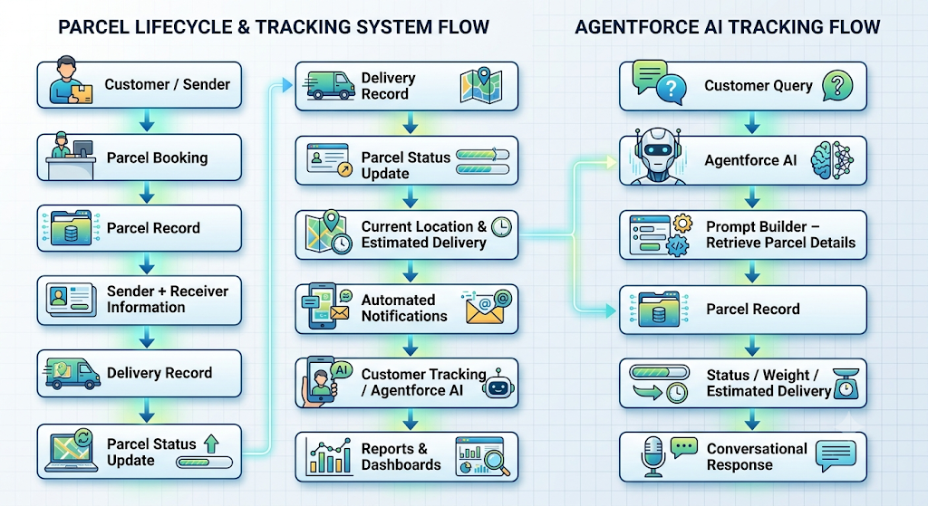
The Prompt Builder implementation retrieves Parcel ID, Status, Weight, and Estimated Delivery Date information for tracking responses.

3.4 Technology Stack
- Platform: Salesforce Developer Edition
- UI: Lightning App Page, Lightning Record Pages, Experience Cloud
- Database: Salesforce Custom & Standard Objects
- Business Logic: Salesforce Flows, Apex Classes
- Automation: Record-Triggered Flows, Auto-Launched Flows, Scheduled Flows
- AI: Agentforce AI, Prompt Builder
- Notifications: Email Alerts & Email Templates
- Processing: Batch Apex
- Security: Profiles, Permission Sets, Role Hierarchy, Field-Level Security, Sharing Rules
- Reporting: Reports & Dashboards

4. PROJECT DESIGN PHASE

4.1 Problem–Solution Fit
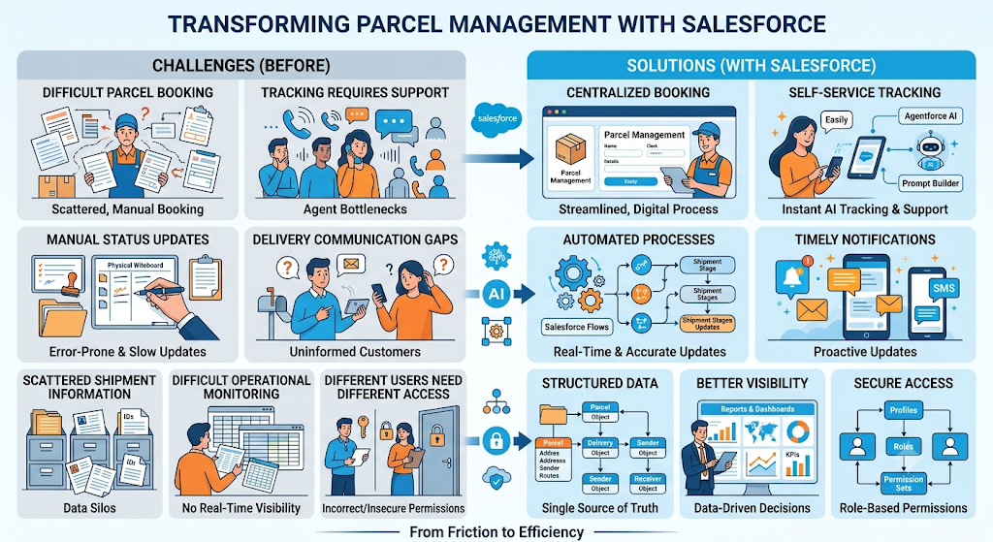

4.2 Proposed Solution
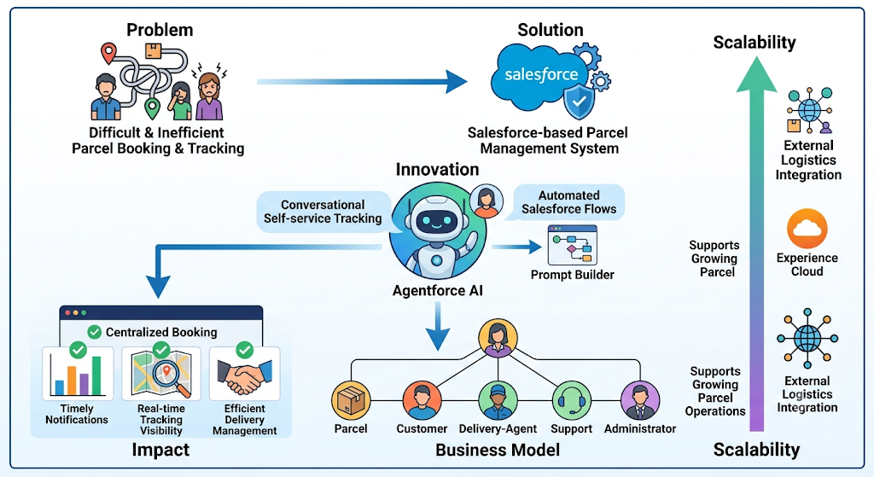

4.3 Solution Architecture
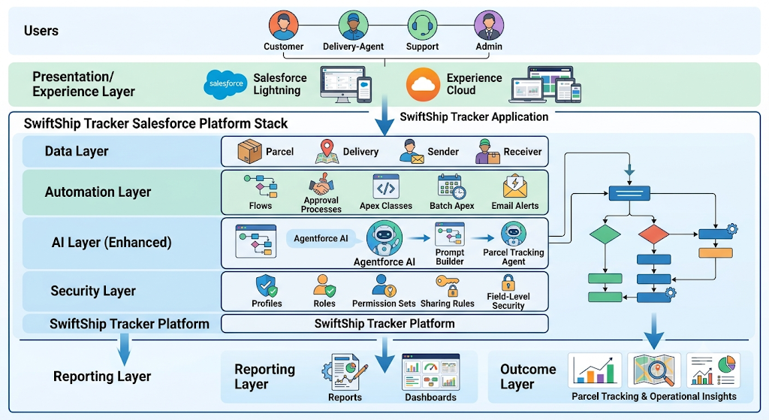

5. PROJECT PLANNING & SCHEDULING

5.1 Project Planning
The project follows an Agile methodology using Epics, User Stories, Story Points, sprint-based execution, and velocity-based estimation.

6. PROJECT DEVELOPMENT PHASE

Phase 1: Requirement Analysis & Planning
Objective:
Customers can experience delays and confusion while booking, tracking, and managing parcel deliveries when they need to contact support or use multiple applications. A conversational AI agent can simplify the process by allowing customers to book parcels, obtain tracking information, and manage deliveries in one place.
Key requirements:
- Gather requirements from end users and delivery agents.
- Define system scope and user personas: Customer, Agent, and Admin.
- Design the data model and relationships among Parcel, Sender, Receiver, and Delivery.
- Identify use cases such as parcel booking, tracking, and delivery-update automation.
- Select Salesforce Flows, Prompt Builder, and Agentforce AI.

Defining Project Scope & Objectives
Project Scope:
- 1. Build a scalable CRM solution for parcel delivery businesses to manage customer bookings, shipments, and delivery operations efficiently.
- 2. Support the complete parcel lifecycle from booking to dispatch, tracking, and delivery confirmation.
- 3. Include data model design, automation through Flows, Apex and Email Alerts, AI-powered Prompt Builder, and reporting dashboards.
- 4. Provide role-based access for administrators, delivery agents, and customers through Salesforce profiles, permission sets, and Experience Cloud.
- 5. Provide real-time parcel visibility for customers and simplified operational tracking for agents through AI-integrated conversational support.
Objectives:
- Streamline parcel operations through automated booking, tracking, and delivery notifications.
- Improve customer experience through transparent shipment status and self-service tracking.
- Enhance agent efficiency through centralized dashboards and guided Flows.
- Provide business insights through reports and dashboards.
- Maintain security and reliability using role hierarchies, sharing rules, and controlled data access.

Gathering & Analysing User Needs
Users involved:
- Customers / Senders – Book parcels, track deliveries, and receive updates through the portal or AI agent.
- Delivery Agents – Manage assigned parcels and update delivery status.
- Customer Support Team – Handle delivery-related issues and customer queries.
- Admin Team – Configure Salesforce, manage user roles and security, and monitor performance.
- System Integrator / Developer – Implement automation, AI agent configuration, and backend integrations.

Key functional needs:
- Seamless parcel booking and tracking through Salesforce Experience Site or agent assistance.
- Real-time agent updates through stages such as Booked → In Transit → Out for Delivery → Delivered.
- Automated notifications and email alerts for delivery-stage updates.
- Sender and Receiver details management.
- AI Agent integration through Prompt Builder.
- Reports and dashboards for parcel flow, delivery performance, and agent activity.
- Security controls using roles, profiles, and permission sets.

Tools Used
- Salesforce Developer Org – Configuration, development, and testing
- Prompt Builder / Agentforce AI – Intelligent parcel tracking prompts and responses
- Salesforce Flow Builder – Booking, tracking, and delivery automation
- Google Sheets / Docs – Initial data planning, documentation, and system mapping

Identifying Key Salesforce Features & Tools Required
Salesforce features planned:
- Custom Objects: Parcel__c, Delivery__c, Sender__c, Receiver__c
- Standard Objects: Account, Contact, Case, Task, EmailMessage, User
- Automations: Record-Triggered Flows, Auto-Launched Flows, Approval Processes, Scheduled Flows
- Apex: Apex Classes for parcel operations and Batch Apex for periodic processing
- UI: Lightning App Page, Dynamic Forms, Lightning Record Pages, Experience Cloud
- Agentforce AI & Prompt Builder: Fetch parcel data using Parcel ID and respond to tracking queries
- Email Services: Custom Email Alerts and Templates
- Security: Profiles, Permission Sets, Role Hierarchies, Field-Level Security, Sharing Rules

Designing Data Model and Security Model
Data Model:
- Parcel__c – Stores Parcel ID, Status, Weight, and Estimated Delivery Date. It is linked with Sender__c and Receiver__c and connected with Delivery__c for tracking.
- Delivery__c – Stores current location, estimated delivery date, and parcel-related delivery information.
- Sender__c – Stores sender address, contact number, and email information.
- Receiver__c – Stores receiver address, contact number, and email information.
Security Model:
- Role Hierarchy: Administrator → Delivery Manager → Agent → Customer
- Admin Profile: Full access to objects and records.
- Delivery Agent Profile: Read/Edit access to Parcel, Delivery, Sender, and Receiver.
- Customer Profile: Read-only access to their own parcel details through Experience Cloud.
- Support Staff Profile: Access to Cases and Parcel details for issue resolution.
- Permission Sets: Provide additional privileges such as delivery-status updates and Agent Console access.
- Record-Level Security: Sharing Rules control access to Parcel__c and Delivery__c.
- Field-Level Security: Sensitive sender email, receiver contact, and location fields are restricted to appropriate profiles.

Phase 2: Salesforce Development – Backend & Configurations
This phase focuses on implementing the core SwiftShip Tracker logic. Custom objects are created for Parcel, Sender, Receiver, and Delivery with relationships. Flows and approval processes are used to automate parcel status updates and operational activities.

Milestone 1 – Salesforce Account
Salesforce is a customer success platform designed to support sales, service, marketing, analytics, and customer engagement.
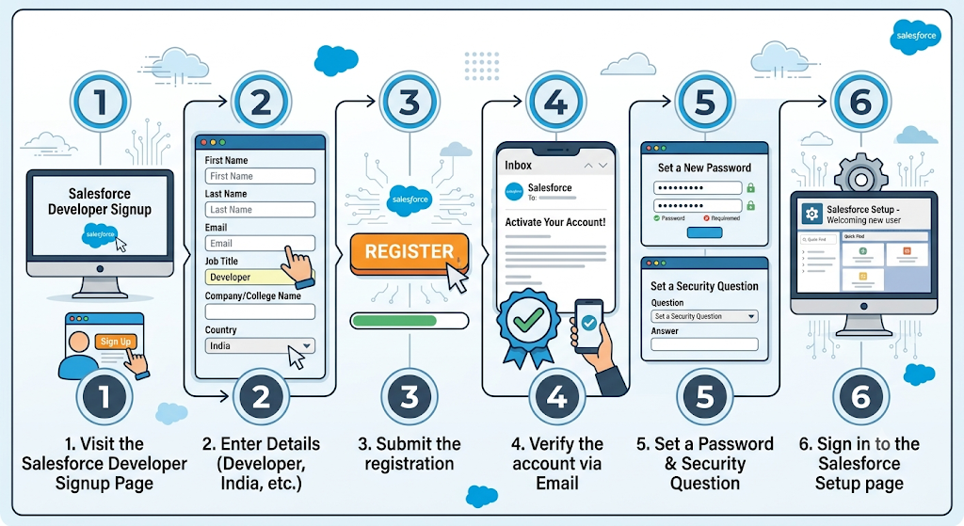

Milestone 2 – Objects Creation
Parcel Object:
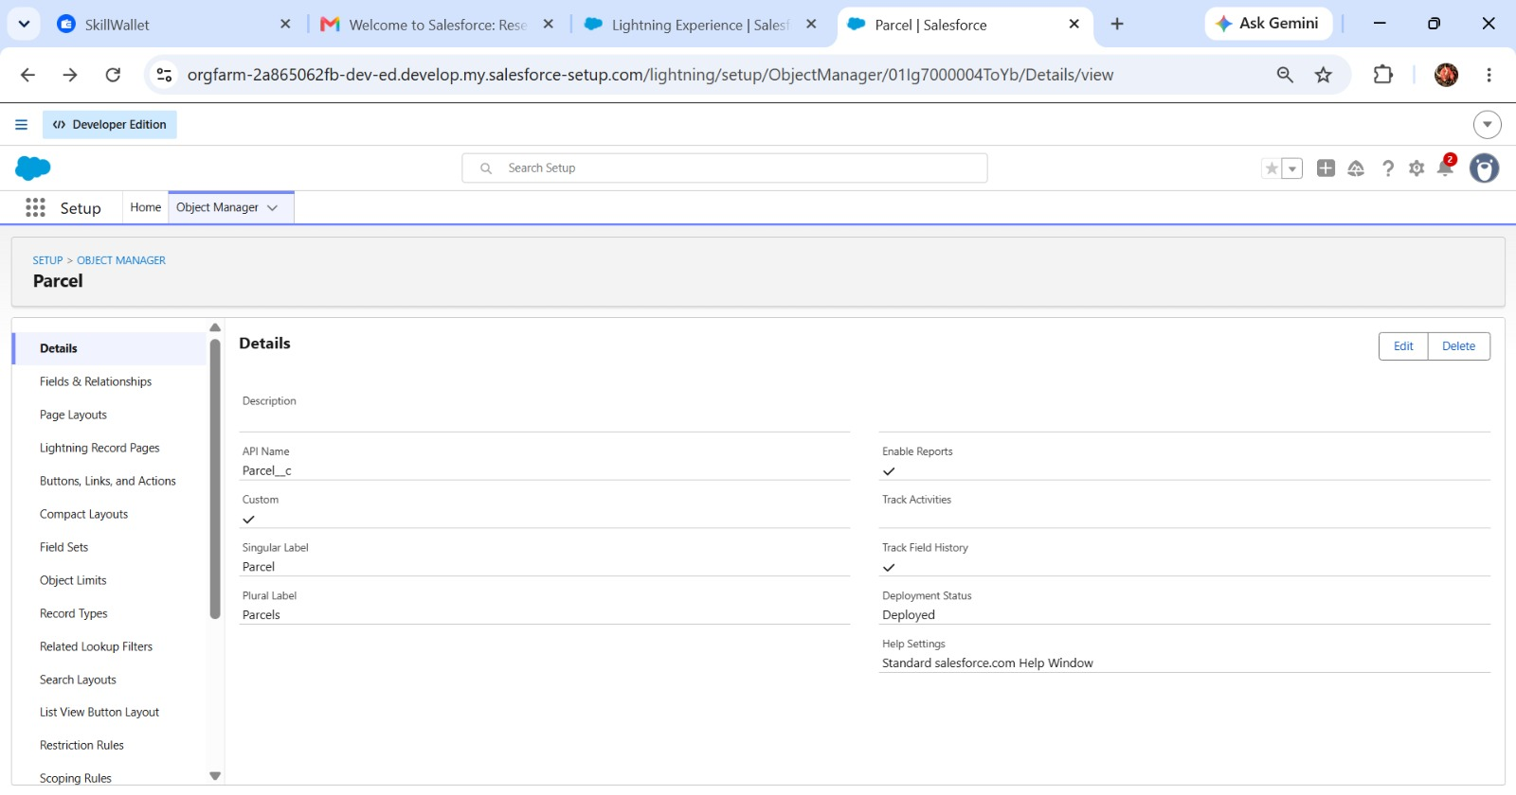
Delivery Object:
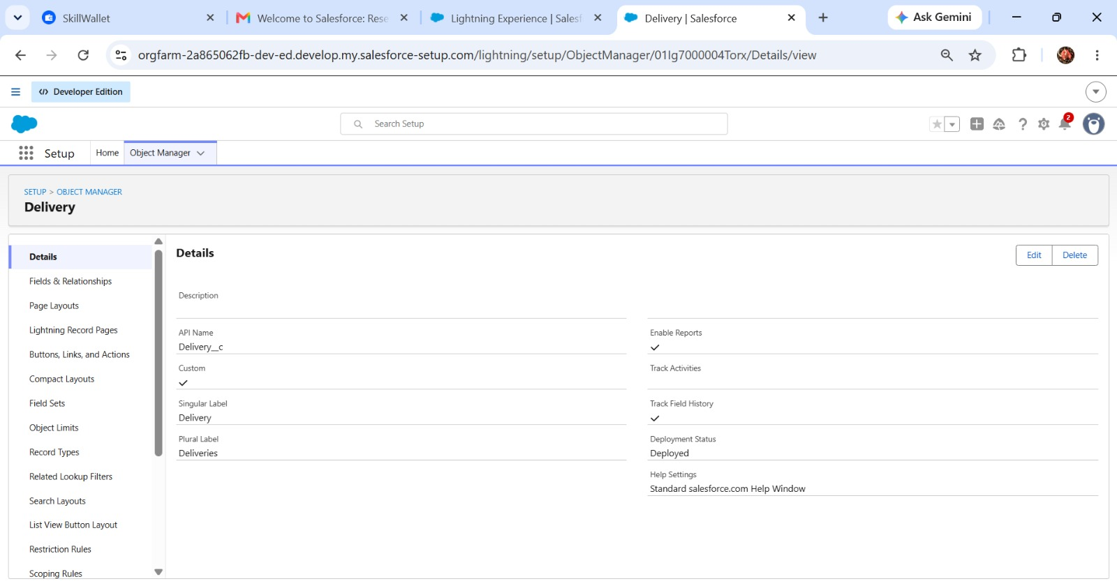

Sender Object:
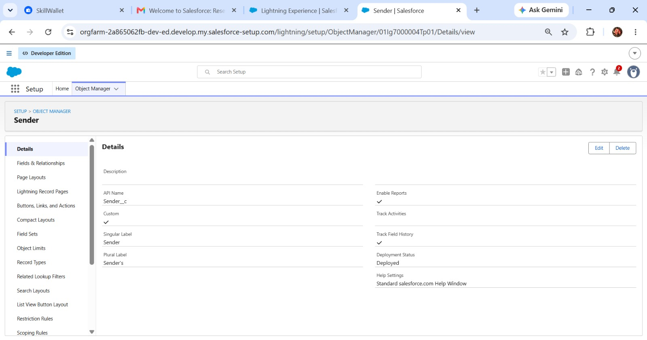

Receiver Object:
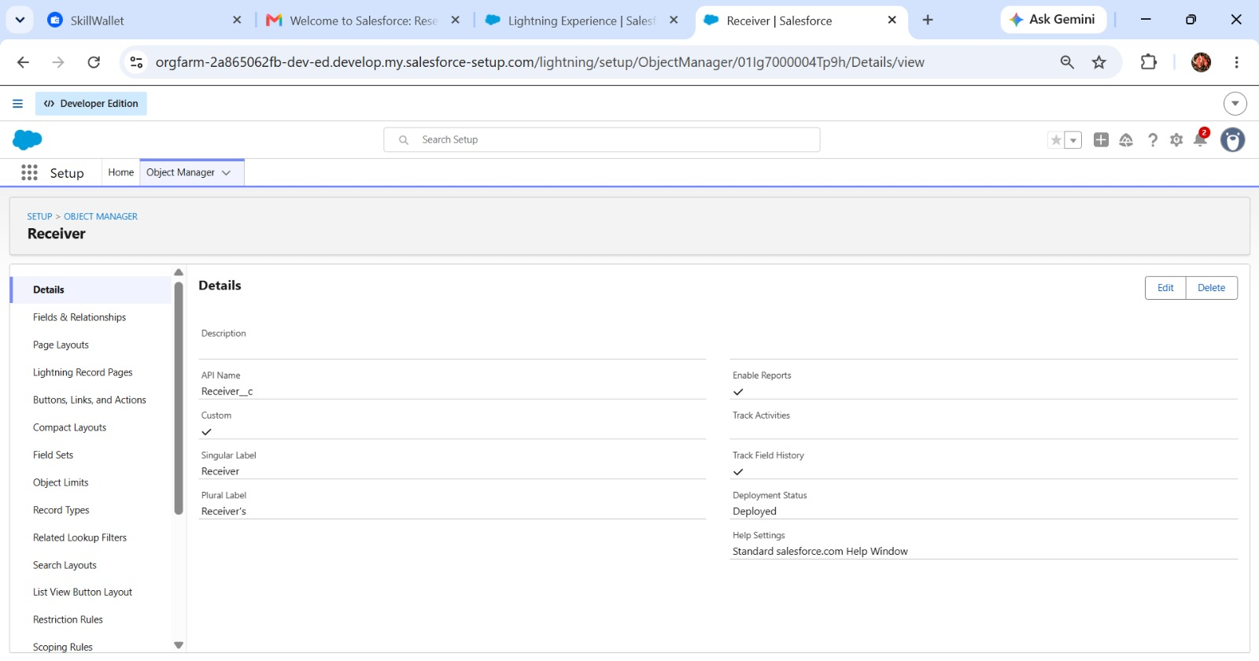

Milestone 3 – Tabs
To create a Parcel tab:
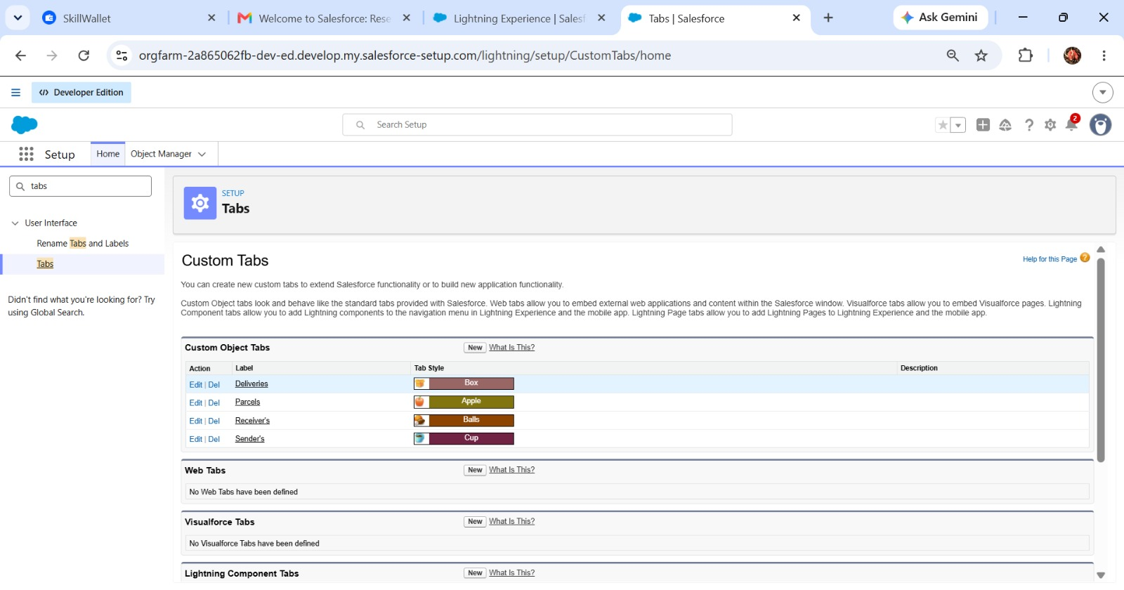

Milestone 4 – Fields & Relationships
Parcel Object:
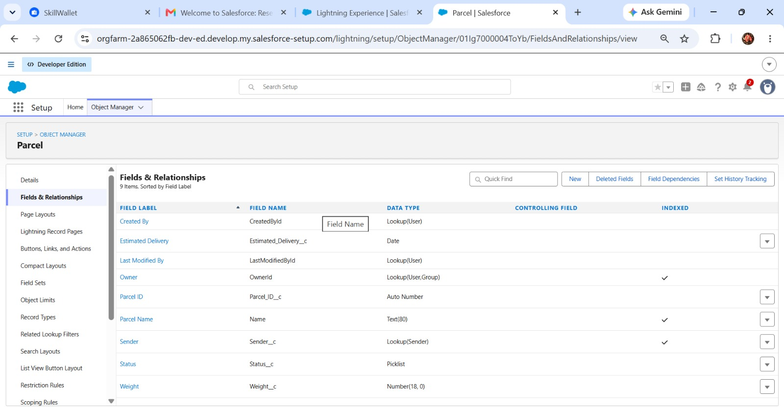

Delivery Object:
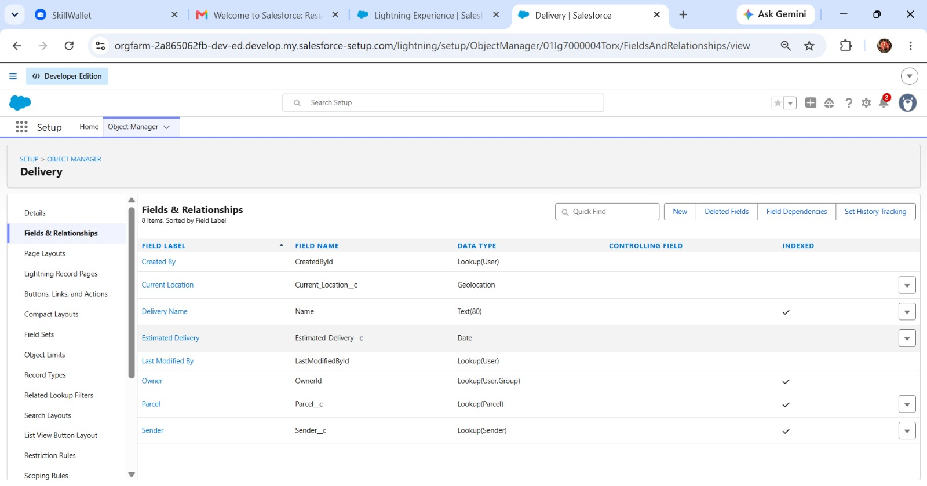
Sender Object:
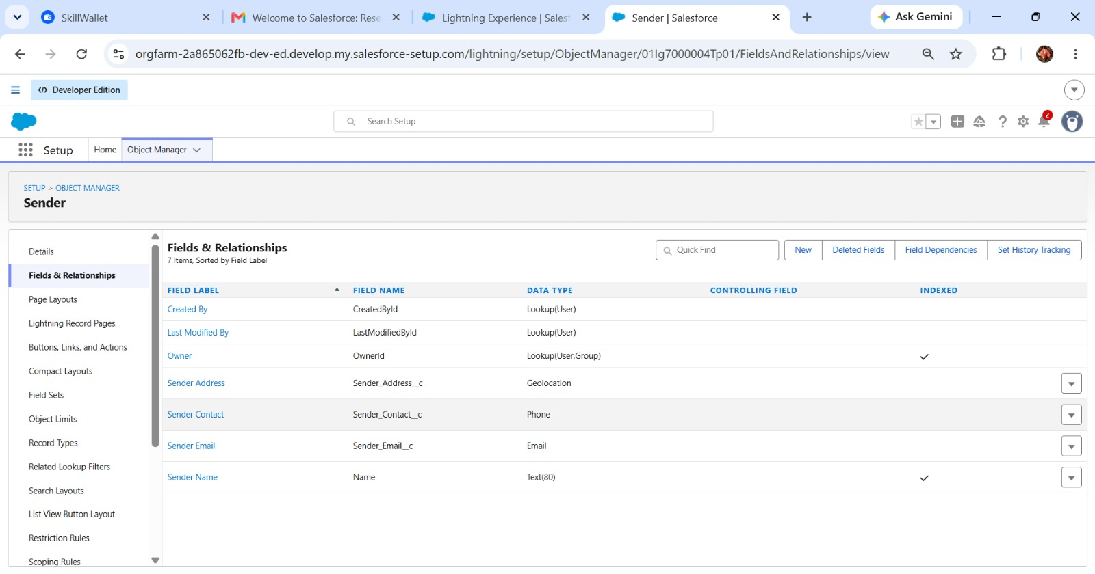

Receiver Object:
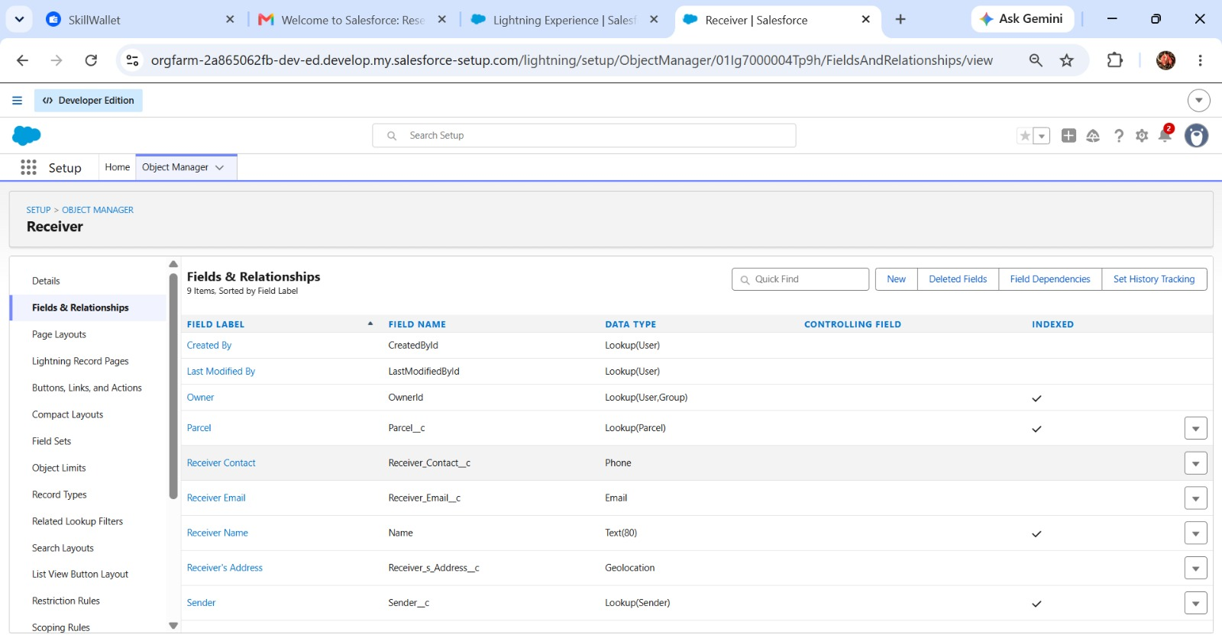

Milestone 5 – Prompt Builder
Create a Prompt Template for retrieving parcel details.
Testing:
Use the Agent preview and enter a request such as “Track parcel P-12345” to retrieve the corresponding Parcel record details.

Milestone 6 – Flows
Create an Auto-Launched Flow (No Trigger).
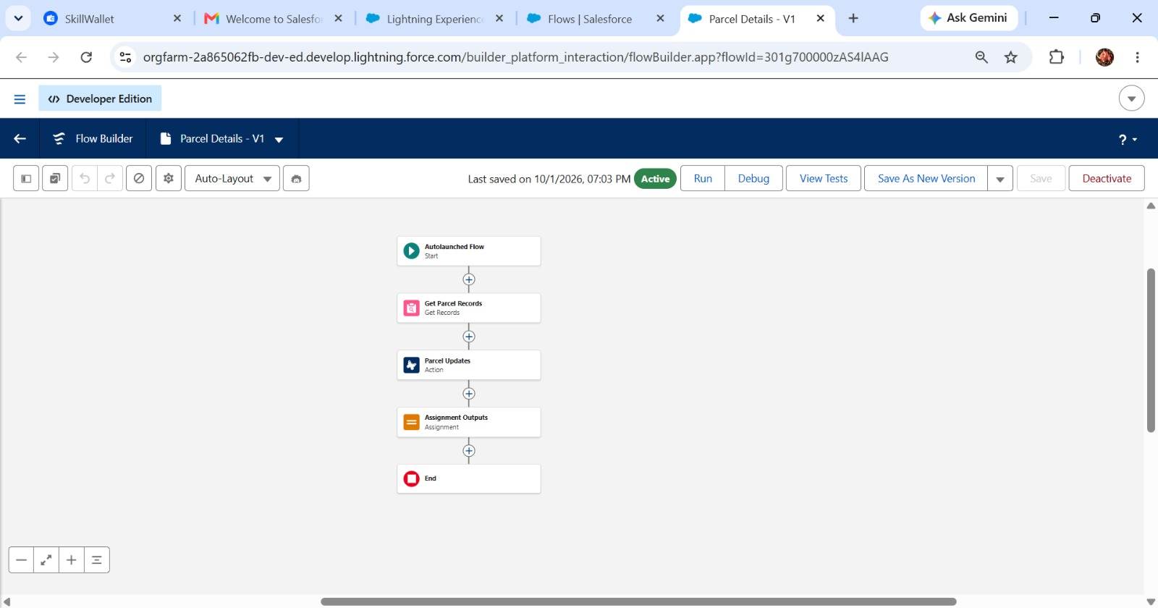

Phase 3: UI/UX Development & Customization
This phase focuses on enabling agents to manage parcel operations efficiently while maintaining secure access through permission sets and AI-driven Agentforce experiences.

Milestone 1 – Creating Permission Sets
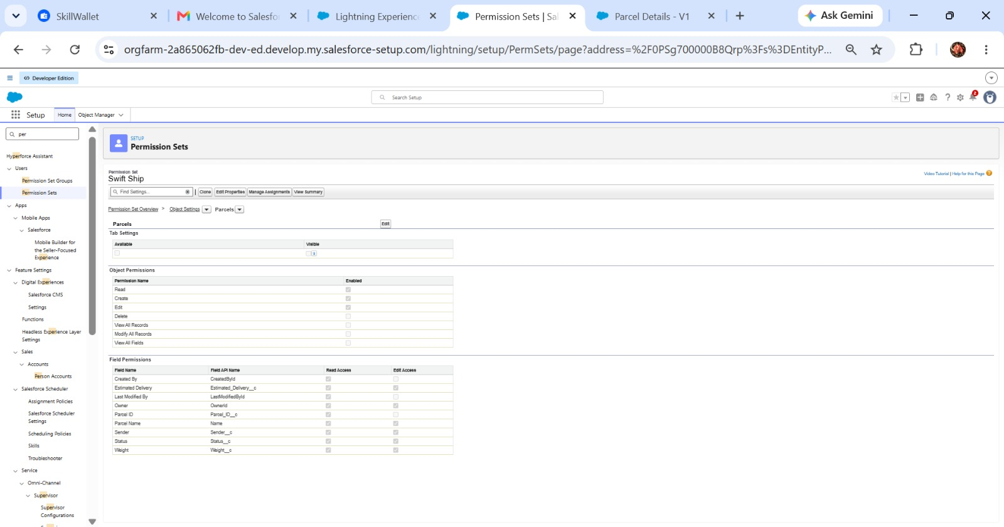

Milestone 2 – Assigning Permissions to the Agent User
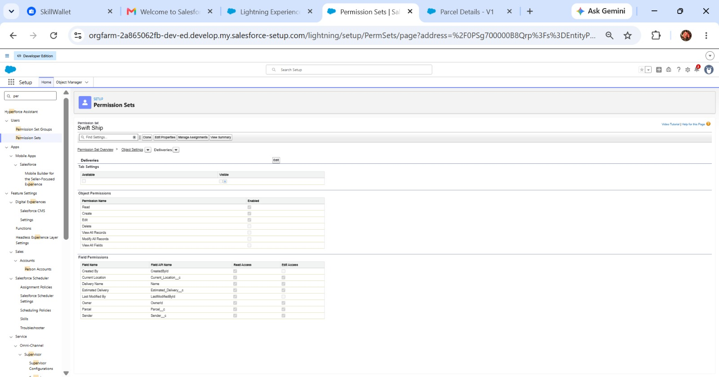

Milestone 3 – Org Setup for Agentforce
Enable the Salesforce default agent from Salesforce Go and turn on the required services.
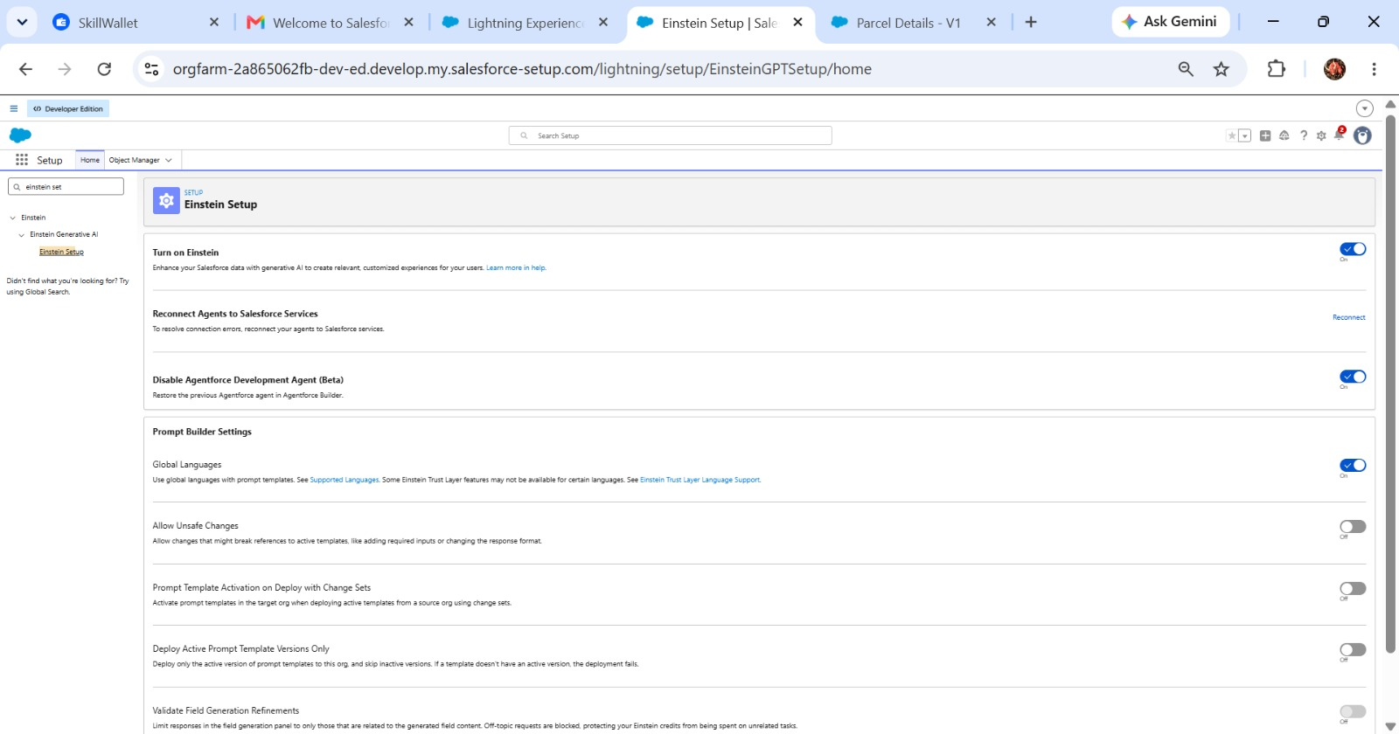

Milestone 4 – Building the Agent
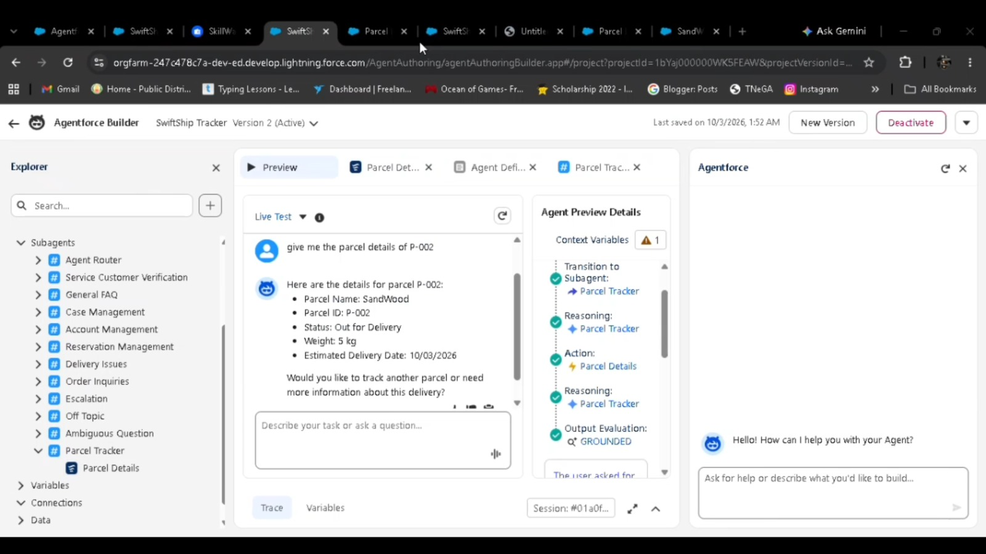

Phase 4: Data Migration, Testing & Security
This phase validates the functionality and reliability of the Parcel Tracking Agent. It verifies topic recognition, Flow execution, parcel-data retrieval, and permission handling so that the AI-driven agent operates correctly within Salesforce.

Phase 5: Deployment, Documentation & Maintenance
The purpose of this phase is to validate the Parcel Tracking Agent within the Salesforce Developer Org. Testing focuses on topic recognition, Flow execution, data retrieval, permissions, and agent interaction.
The project is tested within the Developer Org to simulate live behavior before deployment. Production UAT, sandbox deployment, and enterprise CI/CD are outside the scope of this academic/prototype implementation because the Developer Edition environment is a standalone learning environment.
Maintenance and monitoring include:
- Monitoring Parcel, Customer, and Delivery data.
- Detecting incorrect agent queries, failed Flows, and performance delays.
- Resolving configuration errors.
- Updating Flow logic.
- Refining agent topics.
- Improving prompts and conversational interactions.
- Monitoring scalability and reliability in future enterprise deployments.

7. FUNCTIONAL & PERFORMANCE TESTING
During testing, Salesforce screenshots were captured to validate the implemented functionality. The project verifies parcel creation, delivery assignment, status updates, automation, agent interactions, data retrieval, permissions, and dashboard-related functionality. The source document also notes that testing was used to verify correct functionality and performance.

8. ADVANTAGES & DISADVANTAGES
Advantages:
- Centralizes parcel and customer information in Salesforce.
- Improves visibility into parcel booking and delivery tracking.
- Automates key logistics processes using Salesforce Flow.
- Agentforce supports conversational customer assistance and parcel-status queries.
- Prompt Builder enables AI-powered responses and self-service.
- Reduces manual effort for customers, support teams, and administrators.
- Provides timely delivery notifications and updates.
- Experience Cloud can provide convenient customer access to tracking information.
- Supports integration with external logistics systems.
- Can scale for multiple locations and growing parcel operations.
Disadvantages:
- Requires accurate and up-to-date parcel and customer data.
- Depends on Salesforce configuration and automation.
- Agentforce responses depend on properly configured prompts and available data.
- External logistics integrations can increase implementation complexity.
- Flow and automation logic require maintenance when business processes change.
- Users need appropriate Salesforce or Experience Cloud access.
- Initial implementation and configuration can require significant effort.
- Expansion to additional locations or integrations may require further customization.

9. CONCLUSION
SwiftShip Tracker demonstrates how Salesforce can be used to develop a centralized parcel management and tracking solution. The project combines custom objects, relationships, Flows, Apex, Email Alerts, Experience Cloud, Agentforce AI, Prompt Builder, security controls, and reporting to support parcel booking, delivery tracking, status updates, and customer communication.
The integration of Agentforce AI with Prompt Builder and Salesforce Flow provides a conversational approach to parcel tracking. It allows customers to obtain shipment information without depending entirely on manual support. Overall, the project provides a practical foundation for a scalable and user-friendly parcel management solution.

10. FUTURE SCOPE
- Extend Agentforce capabilities for additional parcel-management queries.
- Enhance real-time delivery tracking.
- Expand customer self-service through Experience Cloud.
- Add advanced delivery-performance analytics.
- Integrate additional external logistics systems.
- Improve AI prompts and conversational experiences.
- Introduce enterprise-level sandbox and CI/CD deployment.
- Expand automation for additional parcel operations.
Future enhancements can also include continuous monitoring, prompt refinement, Flow improvement, and increased AI-agent scalability.

11. APPENDIX

- Custom Objects: Parcel, Delivery, Sender, Receiver
- Standard Objects: Account, Contact, Case, Task, EmailMessage, User
- Automation: Flows, Approval Processes, Email Alerts
- Apex: Apex Classes, Batch Apex
- AI: Agentforce AI, Prompt Builder
- UI: Lightning App, Lightning Record Pages, Experience Cloud
- Security: Profiles, Roles, Permission Sets, Sharing Rules, Field-Level Security
- Analytics: Reports & Dashboards
- Testing: Flow, Agentforce, data retrieval, security, and permission validation

